OVERVIEW

There are times when you will want to test different parts of the costings publication system. This index will help you figure out what to look for where.
In the UI:
- Generate the JSON (we think it takes everything from the BCS tables)
- Download from the azure folder to look at it (… if you have a bad json, stop here + redo.)
- Publish that JSON
- Trigger the Scheduler and watch the magic happen in the catalog DB

In Azure:
- Navigate to the QA folder for EN SHIPPING. (or PROD if that’s where you are)
  - Remember your IP has to be whitelisted to see these folders
- Remember if you aren’t publishing to all tenants, remove the folder for the tenants you want to skip.
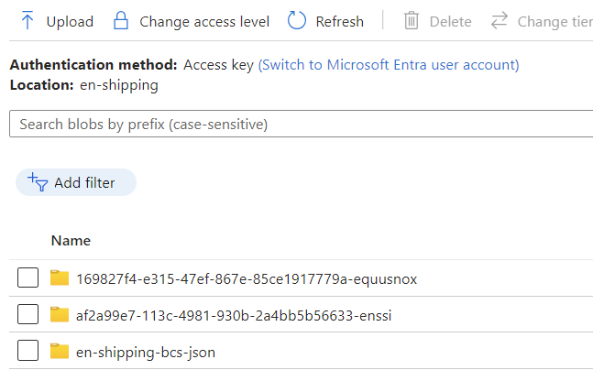
In the DB:
- EN DB QA
- EN (or ALPHA, BETA, etc.) Tenant QA
- Catalog DB QA
In Excel:
- JSON Exploder Instructions if you are not remembering how to import
- EN to TENANT testing spreadsheet for each tenant (JSON is same for any number of tenants)
- Costings to Shipping

UI Screens
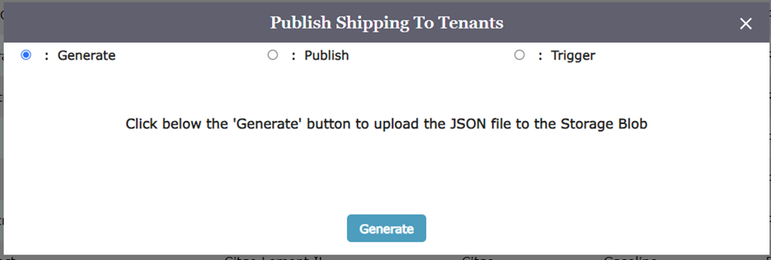
The Publish Button in the UI is visible only to EN users. This is the main set of screens used to publish costings to shipping and shipping to tenants.
There are three functions:
GENERATE: This will make a SHIPPING JSON file and save it in the EN SHIPPING FOLDER. There are no user inputs. The file is automatically written out to the QA version of this folder when the QA UI is used: https://saeastusqa001.blob.core.windows.net/en-shipping
PUBLISH: Select the file you want to push out to the tenants. This will ask you to select the file. The most recent file you published will be at the top of the list and will have a name like: SHIPPING BCS YYYYMMDD HHMMSS.json
TRIGGER: Start a thing happening. There are several things in this list now and we expect to have more as the software develops more features. User inputs are required for these triggers.
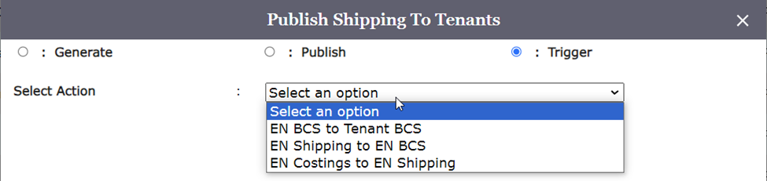

EN Costings to Shipping: Put in the date now or in the future. This query hits the start and end date in the costing table to figure out which costings to publish and how to fill in the shipping period.
EN Shipping to EN BCS: Put the date that you want any records having been modified in the terminal market or shipping period table = or greater than this date.
EN BCS to TENANT BCS: Put the date and time (IN YOUR COMPUTER TIME) that you want the file to begin ETL.

JSON EXPLODER
You will want to remember how to import a JSON file into excel along the way in the process. If you haven’t done it lately, here are some tips for THIS specific EN SHIPPING JSON.
- In the upper left corner, use menu to Get Data>From File>From JSON
- Import the newly downloaded file
- In the upper left corner use To Table Convert button to get started
- Choose None, Show as Errors in the initial dialogue
- Expand the columns by using the double arrow that appears on the right column of the table
- Always be looking for this to be UNCHECKED: Use original column name as prefix
- Keep scrolling right, doing the expanding again selecting Expand to New Rows until you have fully expanded all columns (3 full times to get all table data).
- In the upper left corner, use Close and Load to insert a new tab with this data in your file.

QUERY INDEX

